- Category of Submission

Which event are you submitting for? *
IHI In-Person Forum: ☐ IHI Virtual Forum ☐ IHI Virtual Scientific Symposium ☐

If not accepted into the Forum, would you be interested in applying to the Scientific Symposium? (If you select "Yes" you will need to fill out Scientific Symposium fields including a second version of your session description. Refer to Symposium drafting form to view additional fields: authors, new description, permissions). *
For more information on the Scientific Symposium and to see if your submission would be a good fit please click here.
Yes: ☐ No: ☐

- Main Submission Details

Presentation Title (100 Characters including spaces): * Title should be descriptive and engaging, avoiding acronyms and exclamation points. Please limit the presentation title to 100 characters, including spaces.
Click or tap here to enter text.

Subject Matter Focus – Please Select One (descriptions below) *
Addressing Value, Cost and Quality: ☐ Equity ☐ Leadership: ☐ Improvement Science: ☐ Person-Centered Care ☐ Population Health: ☐ Workforce and Patient Safety: ☐ Workforce Well-Being ☐

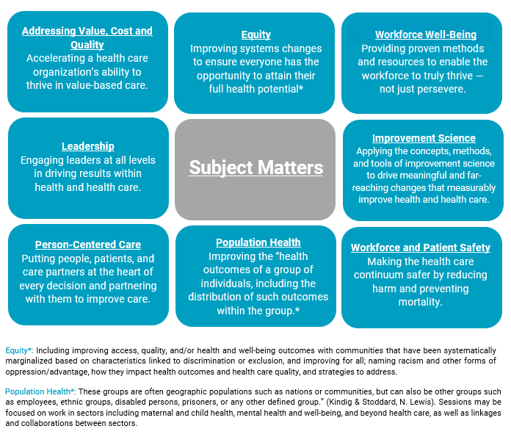

- Submission Description
Summary of Poster (250 Word limit) *
The summary will need to be 250 words or less. Your description will be published as entered below in conference materials if accepted so please review it for accuracy before submitting.

You are required to include the following information:
- Description of the Problem or Purpose
- Actions Taken
- Summary of Results
- Lessons Learned
Click or tap here to enter text.

- Poster PDF

Attachments
Poster submissions require a completed version of your poster uploaded in PDF form. You can upload your PDF in the submission portal. The requirements for this can be found on the poster guidelines section located here.

Please make sure your poster is finalized before uploading. Accepted posters regardless of in-person or virtual will be displayed in the virtual Forum.

- Presenters

Presenter Information *
You may include all co-authors who contributed in a significant way to the work. Please include yourself when submitting this information.

Example: Chris Jacobs, MPH, Brigham and Womens, Director of Family Medicine; Sally Erwin, MD, Enmity Health, Vice President;

For each presenter you will need to prepare the following fields to be entered into the online form.

First Name Company
Last Name Credentials
Job Title Email Address (optional)

Poster Author Information: * Click or tap here to enter text.

