- Category of Submission

If I am not selected for a speaking session, I wish to be considered for a poster. Poster submissions are limited to 1 per person. If you have submitted more than one session proposal, IHI will give you the opportunity to select the proposal you wish to submit as your final poster submission. *
Yes, consider me for a poster: ☐
No, do not consider me for a Poster: ☐

If not accepted into the Forum, would you be interested in applying to the Scientific Symposium? (If you select "Yes" you will need to fill out Scientific Symposium fields including a second version of your session description. Refer to Symposium drafting form to view additional fields: authors, new description, permissions). *
For more information on the Scientific Symposium and to see if your submission would be a good fit please click here.
Yes: ☐
No: ☐

- Main Submission Details

Presentation Title (100 Characters including spaces): * Title should be descriptive and engaging, avoiding acronyms and exclamation points. Please limit the presentation title to 100 characters, including spaces.
Click or tap here to enter text.

Subject Matter Focus – Please Select One (descriptions below) *
Addressing Value, Cost and Quality: ☐
Equity ☐
Leadership: ☐
Improvement Science: ☐
Person-Centered Care ☐
Population Health: ☐
Workforce and Patient Safety: ☐
Workforce Well-Being ☐

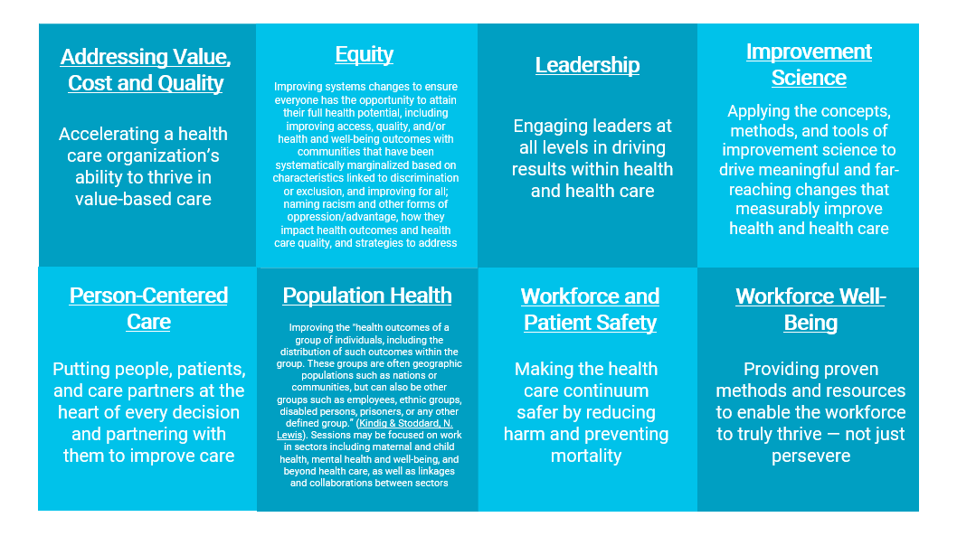

Does your submission fit under any other subject matters? *
Yes: ☐ (If yes, please mark one to two additional subject matters below)
No: ☐

Addressing Value, Cost and Quality: ☐
Equity ☐
Leadership: ☐
Improvement Science: ☐
Person-Centered Care ☐
Population Health: ☐
Workforce and Patient Safety: ☐
Workforce Well-Being ☐
Does your submission include content on COVID-19? *
Yes: ☐
No: ☐

Population Focus – Please Select One *
All Populations: ☐
Communities of Color: ☐
Individuals disproportionately affected by inequities: ☐
Individuals/patients at the end of life: ☐
Individuals/patients with chronic conditions: ☐
Individuals/patients with complex health or care needs: ☐
Individuals/patients with mental health and/or substance use disorders: ☐
Infants and/or children: ☐
LGBTQIA+: ☐
Infants and/or children: ☐
Migrant/Immigrant and Incarcerated Populations: ☐
Military/Veteran: ☐
Mothers/Birthing Persons and/or Newborns: ☐
Older Adults ☐
Population Segments by Payor: ☐
Populations in Rural Areas: ☐
Specific Geographic/Community Populations: ☐
Teens and/or Young Adults: ☐
Subtopic Area – Please Select 1-3 *
Based on the main subject matter area you selected, you will need to select subtopic areas that will help the IHI Forum committee review your proposal in further detail. There are a large variety of subtopic areas which can be found in the online application.

- Learner Objectives and Description
Learner Objectives (100 Characters including spaces each) *
Please list a minimum of two or a maximum of three action-oriented SMART objectives.
In order to be in compliance with accreditation guidelines the following verbs are NOT accepted: Know, Comprehend, Understand, Appreciate, Familiarize, Study, Be Aware, Become Acquainted with, Gain Knowledge of, Cover, Learn, Realize. These are not measurable.
Potential action verbs include Access, Develop, Identify and Implement. SMART outcomes are specific, measurable, attainable, relevant and time-based.
Utilize the objective build tool:
https://teachonline.asu.edu/objectives-builder

Objective 1: * Click or tap here to enter text.
Objective 2: * Click or tap here to enter text.
Objective 3: * Click or tap here to enter text.
Session Description (1250 character including spaces limit) *
Descriptions should be either about "Methods, Tools and Frameworks" or "Case Studies from the Field." If the work addresses a range of disciplines, please make sure to include that in the description. Your description will be published if accepted so please make sure it is free of grammatical errors.
Option A. Methods, Tools and Frameworks:
1. Background: What is the need in the field for this method / tool / framework?
2. Description & Audience: What is the method / tool / framework? Who is the intended audience who would benefit from applying it and how does this address interprofessional continuing professional development?
3. Examples / Applications: Will you share any stories and/or case examples from the field that bring method/tool/framework to life?
4. Value to Session Participants: How will participants be able to advance their professional practice as a result of this session?
Option B. Case Studies from the Field:
1. Background: What is the need in the field for this case study
2. Discovery: What was the problem identified that triggered the need for action?
3. Solution: Describe the solution or process developed to resolve the problem and create accountability throughout your organization, community, and to the wider public.
4. Outcome: Describe the outcome measures used to monitor success and sustainability of your best practice. State how the outcome impacted professional development of the professionals involved and how long has your organization sustained these outcomes/results. Describe the methodology for monitoring sustainability and making continuous improvement.
Description: Click or tap here to enter text.

- Frameworks and Attachments
Attachments
We strongly encourage you to submit an attachment that displays the results of your work. Attachments may be added via the online submission form. You may choose to upload a single file. The file MUST contain no more than 5 tables/figures.

Further considerations for attachments:
- We will look for time-ordered data (e.g., run charts, control charts, time series analysis)
- We do not accept pie charts or bar graphs.
- Please make sure all documents/images are high quality and easy to read.
Option A. Methods, Tools and Frameworks: Will you walk through a framework? *
Yes: ☐
No: ☐

Option B. Case Studies from the Field: Will you be submitting a case study with results? *
Yes: ☐
No: ☐
(If your submission includes a framework or a case study with results, including them as an attachment in the online form will increase your chances at acceptance.)

5. Session Structure & Level

Which event are you submitting for? *
General Conference Session: 60 Minutes: ☐
- Mostly didactic in nature, with partial attendee interaction and provide participants with tangible take-aways to apply to their work.
- Dates: Tuesday, December 12 or Wednesday, December 13
- Part of General Conference

Half-Day Pre-Conference Workshop – 3 Hours (including breaks for participants) ☐
- Focus-topic "how to" learning sessions that allow participants to fully engage in discussions and Q&A with world-renowned
experts. Attendees will take home new tools, implement quality improvement practices, and gain and sustain success.
- These workshops are structured to be interactive and provide participants with tangible take-aways to apply to their work.
- Dates: Sunday, December 10 or Monday, December 11
- Part of Pre-Conference

Full-Day Pre-Conference Workshop – 7 Hours (including breaks for participants) ☐
- Presenters teach foundational QI methodologies and practices, allowing participants to take home new tools, implement quality
improvement practices, and gain and sustain success.
- These workshops are structured to be interactive and provide participants with tangible take-aways to apply to their work.
- Dates: Sunday, December 10 or Monday, December 11
- Part of Pre-Conference
Attendee Experience Level *
To help guide our attendees in choosing which sessions they would like to join, we ask that you choose a difficulty level for your session. Please see the levels below.
- Student: Offers a wide range of topics and disciplines that are especially appropriate for students who are new to quality
improvement or the National Forum.
- Novice: Helpful ideas and tools for newcomers to the world of quality improvement. No significant QI knowledge is assumed.
- Intermediate: Attendees with a sound knowledge of quality improvement methodology. Presenters will assume attendees have at
least some experience or knowledge in QI.
- Advanced: Advanced learner and will provide cutting-edge quality improvement thinking.
Student: ☐
Novice: ☐
Intermediate: ☐
Advanced: ☐
All Levels: ☐

- Presenters

Presenter Information *
IHI has a limit of 4 presenters per session. Please consider this limit when planning out the content and structure for your presentation. All additional presenter information must be added including their bio. Presenter photos are welcome but not mandatory.

For each presenter you will need to prepare the following fields to be entered into the online form.

Email Address Job Title
First Name Company
Last Name Short Biography
Credentials Optional Profile Photo

Presenter 1: * Click or tap here to enter text.
Presenter 2: Click or tap here to enter text.
Presenter 3: Click or tap here to enter text.
Presenter 4: Click or tap here to enter text.

Complimentary Registration for Presenters
General Conference (60 Minute Sessions) & Scientific Symposium Presenters
- A maximum of 2 speaking presenters per session are eligible to have their General Conference (December 12 & 13) registration
fees waived.
- This does not include the pre-conference registration days on (Dec 10 & 11) which are an additional fee.
Pre-Conference Presenters - 3 and 7 Hour Workshops
- A maximum of 2 speaking presenters per session are eligible to have their entire conference fees waived (includes all days
December 10-13).
Waived Presenter Names* Click or tap here to enter text.

------------------------------------------------------------------------------------------------------------------------------------------------------------------------------------------------------------------
7. Planning Team

The IHI Forum & Scientific Symposium are looking for sessions that encompass a wide variety of disciplines. It is beneficial but not mandatory for your submission to include a nurse, physician or pharmacist planner. A planner is someone who has significantly contributed to the overall content of the session.

In support of improving patient care, the Institute for Healthcare Improvement is jointly accredited by the Accreditation Council for Continuing Medical Education (ACCME), the Accreditation Council for Pharmacy Education (ACPE), and the American Nurses Credentialing Center (ANCC), to provide continuing education for the healthcare team. IHI offers continuing education credits for a variety of disciplines. In order for your session to be approved for physician, nursing, and/or pharmacy continuing education credits, you must complete the table below.
Did you have a Nurse planner(s) involved in the planning of your session for the IHI Forum?*
Yes: ☐
No: ☐

If yes…..
- Describe how the licensed Nurse was involved in the planning:* Click or tap here to enter text.
- Full Name (Nurse Planner):* Click or tap here to enter text.
- Credentials:* Click or tap here to enter text.
- Job Title:* Click or tap here to enter text.
- Organization:* Click or tap here to enter text.
- Email Address:* Click or tap here to enter text.
- Brief Biography (1-2 paragraphs):* Click or tap here to enter text.

Did you have a Physician planner(s) involved in the planning of your session for the IHI Forum?*
Yes: ☐
No: ☐
If yes…..
- Describe how the licensed Physician was involved in the planning:* Click or tap here to enter text.
- Full Name (Physician Planner):* Click or tap here to enter text.
- Credentials:* Click or tap here to enter text.
- Job Title:* Click or tap here to enter text.
- Organization:* Click or tap here to enter text.
- Email Address:* Click or tap here to enter text.
- Brief Biography (1-2 paragraphs):* Click or tap here to enter text.

Did you have a Pharmacist planner(s) involved in the planning of your session for the IHI Forum?*
Yes: ☐
No: ☐

If yes…..
- Describe how the licensed Pharmacist was involved in the planning: * Click or tap here to enter text.
- Full Name (Pharmacist Planner): * Click or tap here to enter text.
- Credentials: * Click or tap here to enter text.
- Job Title: * Click or tap here to enter text.
- Organization: * Click or tap here to enter text.
- Email Address: * Click or tap here to enter text.
- Brief Biography (1-2 paragraphs): * Click or tap here to enter text.

- Mandatory Presenter & Planner Disclosures***
To be considered for acceptance into the Forum and Scientific Symposium, ALL SPEAKING PRESENTERS and PLANNERS listed above must complete the disclosure form via the instructions below prior to May 1. Failure to fill out a disclosure for each presenter in your submission will result in dismissal from consideration.

Please send the instructions and the link below to your fellow presenters and planners so that they can complete their disclosures. If you are submitting multiple abstracts you do not need to fill out a disclosure for yourself for each abstract

Disclosure instructions:

Visit IHI.org to login to your IHI account (or create one via the link below if needed).
Create IHI Account Here
Once you’re logged into your account, go to my.ihi.org/Disclosure to complete the IHI Disclosure Form.

Disclosure Form Clarifications

Title of Continuing Education Activity - Please enter "Forum - (Title of your submission)"
Location of Continuing Education Activity - Please enter "Forum"
Start & End Date of Continuing Education Activity - Please enter "December 10-13"
Key Presenter Disclosure *
In addition to the disclosures completed above, we ask that you please give an overall disclosure for the group so that when we are reviewing the proposals we have a brief idea of any additional information we should know.
Does the speaker disclose any relevant financial or nonfinancial relationship(s) with any individual or organization that provides goods and services related to IHI’s business and/or the nature of the presentation? This includes anything of monetary value, including but not limited to salary, other payments for services (e.g. consulting fees or honoraria) and equity interest. A conflict may exist where an interested party and his/her immediate spouse/significant other, or a business associate of an interested party, directly or indirectly benefits or profits as a result of a decision made, or a transaction entered into, by IHI.
Yes: ☐
No: ☐

If yes: please complete any of the applicable options below for all actual, potential or perceived conflicts of interest. *
- Salary:
Yes: ☐
No: ☐
- Royalty:
Yes: ☐
No: ☐
- Stock:
Yes: ☐
No: ☐
- Speakers Bureau:
Yes: ☐
No: ☐
- Consultant:
Yes: ☐
No: ☐
- Other:
Yes: ☐
No: ☐
If yes to any of the above, please describe: * Click or tap here to enter text.
Will the presentation include any off-label or investigational uses? *
Yes: ☐
No: ☐

If yes, please describe: *
Click or tap here to enter text.

Will the presentation include discussion of any commercial products or services, including consulting services? *
Yes: ☐
No: ☐

If yes, do they appear to have a relevant financial relationship or interest or nonfinancial relationship with the manufacturer(s) or distributor(s) of any of the products or provider(s) of any of the services that they intend to discuss: *
Yes: ☐
No: ☐

