

# Participant Communication Kit

# Age-Friendly Health Systems

An initiative of John A. Hartford Foundation and Institute for Healthcare Improvement in partnership with American Hospital Association and   
Catholic Health Association of the United States

*This content was created especially for:*

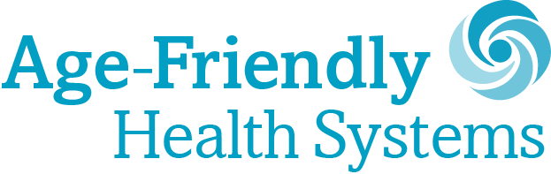

#### 

Contents

Participant Media Kit 1

Age-Friendly Health Systems 1

Welcome to the Age-Friendly Health Systems Movement 3

About Age-Friendly Health Systems 3

Key Messages for the Participants in the Movement 5

Topline Messages 5

Template Press Release 6

Template Newsletter Language 7

Template Blog Post Language 8

Template Social Media Language 9

Brand Guidelines 10

Participant Badge 10

Written Style 10

Descriptive Statement 11

4Ms and the 4Ms Framework for Age-Friendly Care 11

## Welcome to the Age-Friendly Health Systems Movement

Congratulations! You are part of a rapidly growing movement of Age-Friendly Health Systems. Our founding partners, The John A. Hartford Foundation, Institute for Healthcare Improvement, American Hospital Association, and Catholic Health Association of the United States applaud your hard work. This is an exciting movement and there is much to be proud of as, together, we improve the health and health care of older adults.

To help your system talk about its involvement in the initiative and to raise awareness of the broader Age-Friendly Health Systems movement within your community, we've compiled a suite of communications materials which can be customized to your organization. We encourage you to spread the word about your involvement in the Age-Friendly Health Systems initiative through your various communications platforms and channels.

If you have any questions along the way, please email [afhs@ihi.org](mailto:afhs@ihi.org). Thank you!

### About Age-Friendly Health Systems

In 2017, The John A. Hartford Foundation (JAHF) and the Institute for Healthcare Improvement (IHI), in partnership with the American Hospital Association (AHA) and the Catholic Health Association of the United States (CHA), set a bold vision to build a social movement so that all care with older adults is age-friendly care. According to our definition, age-friendly care:

​​​​​​​Five prototyping pioneer health systems stepped forward to work with IHI to test ideas and learn what it takes to be an Age-Friendly Health System. The 4Ms Framework for Age-Friendly Care that emerged is both evidence-based and able to be put into practice reliably in health care settings.

Five Age-Friendly Health Systems Pioneers:

Anne Arundel Medical Center (Headquarters: Annapolis, MD)  
Ascension (Headquarters: St. Louis, MO)  
Kaiser Permanente (Headquarters: Oakland, CA)  
Providence St. Joseph Health (Headquarters: Renton, WA)  
Trinity Health (Headquarters: Livonia, MI)

An Age-Friendly Health System is one in which every older adult’s care:

* Is guided by an essential set of evidence-based practices (the 4Ms);
* Causes no harms; and
* Is consistent with What Maters to the older adult and their family.

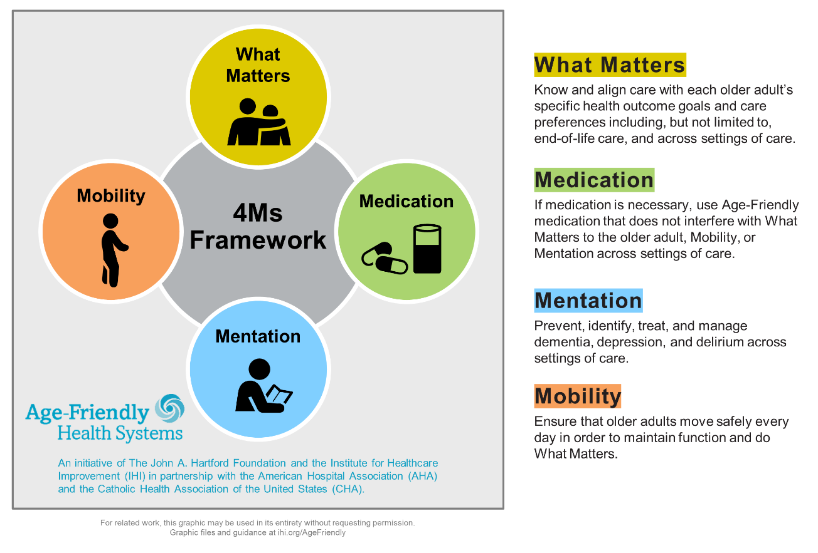

### Action Community – Putting the 4Ms into Practice

In Age-Friendly Health Systems Action Communities, teams from across different health systems come together to accelerate their progress toward providing reliable 4Ms care. Age-Friendly Health System Action Community participants use rapid-cycle testing to introduce and spread the 4Ms Framework in hospital and ambulatory settings and sharedata and learnings with the community.

Please find upcoming opportunities to join an Action Community on [www.ihi.org/AgeFriendly](http://www.ihi.org/AgeFriendly).

To find the most up-to-date numbers of Age-Friendly Health Systems Participants and organizations recognized as Committed to Care Excellence, please go to [www.ihi.org/AgeFriendly](http://www.ihi.org/AgeFriendly).

## 

## Key Messages for the Participants in the Movement

### Topline Messages

**[Everyone deserves age-friendly health care]  
All older adults deserve safe, high-quality health care that is based on what matters most to them as individuals and delivered reliably in every setting.**

**[We are making it happen]  
[ORGANIZATION] is leading the way in making sure that every day, every older adult receives age-friendly health care.**

**[We are using the 4Ms as our framework]  
As part of the Age-Friendly Health Systems movement, we are among the first health systems in the country implementing age-friendly health care.**

The four essential elements of an Age-Friendly Health System are known as the 4Ms:

* What Matters: Know and align care with each older adult's specific health outcome goals and care preferences in​clu​ding, but not limited to, end-of-life care, and across settings of care.
* Medication: If medication is necessary, use Age-Friendly medications that do not interfere with What Matters to the older adult, Mobility, or Mentation across settings of care.
* Mentation: Prevent, identify, treat, and manage dementia, depression, and delirium across settings of care.​
* Mobility: Ensure that older adults move safely every day in order to maintain function and do What Matters.

**[Partner with us!]  
Together we will continue improving the care of older adults and, in doing so, make lasting change in our communities.** See ihi.org/AgeFriendly for opportunities to join the movement.

​​

### Template Press Release

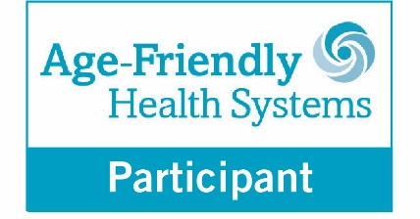

**[YOUR LOGO HERE]**

FOR IMMEDIATE RELEASE Contact: XXXX

[NAME OF ORGANIZATION] PARTICIPATES IN NATIONAL ‘AGE-FRIENDLY HEALTH SYSTEMS’ INITIATIVE

[CITY, STATE] — [NAME OF ORGANIZATION] announced today that it is part of a movement to improve health care for older adults, contributing to a goal continuing to expand and grow Age-Friendly care.

As part of the Age-Friendly Health Systems initiative, [The John A. Hartford Foundation](https://www.johnahartford.org/) and the [Institute for Healthcare Improvement](http://www.ihi.org), in partnership with the [American Hospital Association](https://www.aha.org/front) and the [Catholic Health Association of the United States](https://www.chausa.org/),​ are helping hospitals and other care settings implement a set of evidence-based interventions specifically designed to improve care for older adults.

The interventions can be tested and adapted by participating in Age-Friendly Health Systems Action Communities. These collaborative initiatives bring together health care teams committed to sharing data and learning together. All teams strive toward reliably implementing age-friendly best practices across emergency departments, intensive care units, medical-surgical units, general wards, and primary and specialty care settings.

[NAME OF ORGANIZATION] now joins an international group of more than 2,700 health systems working to tailor care to patients’ goals and preferences and to deliver care that is consistently of the highest quality.

“[ORGANIZATION] has always been on the forefront of patient care, and that’s why we are participating in this vital movement. We look forward to both sharing our best practices and learning what’s working for others proving age-friendly care,” said [NAME], [TITLE] of [ORGANIZATION]. “The Age-Friendly Health Systems initiative is an important part of our overarching vision to provide every older adult with the best care possible.”

The initiative is based on a series of practices focused on addressing four essential elements of care for older patients:

* What Matters: Know and align care with each older adult's specific health outcome goals and care preferences in​clu​ding, but not limited to, end-of-life care, and across settings of care.
* Medication: If medication is necessary, use Age-Friendly medications that do not interfere with What Matters to the older adult, Mobility, or Mentation across settings of care.
* Mentation: Prevent, identify, treat, and manage dementia, depression, and delirium across settings of care.​
* Mobility: Ensure that older adults move safely every day in order to maintain function and do What Matters.

The Age-Friendly Health Systems initiative was launched in 2017 by The John A. Hartford Foundation and IHI, in partnership with the American Hospital Association and Catholic Health Association of the US. For more information, visit [www.ihi.org/agefriendly](http://www.ihi.org/agefriendly).

### Template Newsletter Language

**[YOUR LOGO HERE]**

**[ORGANIZATION] Recognized for Participation in National Movement to Improve Care for Older Adults**

[NAME OF ORGANIZATION] is participating in [Age-Friendly Health Systems](http://ihi.org/Engage/Initiatives/Age-Friendly-Health-Systems/Pages/default.aspx), an initiative of [The John A. Hartford Foundation](http://www.johnahartford.org/) and the [Institute for Healthcare Improvement](http://www.ihi.org), in partnership with the [American Hospital Association](https://www.aha.org/front) and [the Catholic Health Association of the United States](https://www.chausa.org/). As part of the initiative, [ORGANIZATION] is implementing a set of evidence-based interventions designed to improve care for older patients known as the “4Ms” – What Matters, Medication, Mentation, and Mobility. See ihi.org/AgeFriendly to learn more.

### Template Blog Post Language

**Age-Friendly Health Care: What Patients Need and Deserve**

Older adults are living and working longer, redefining later life, and enriching our communities. The future of health care requires bold approaches that value older adults, address their unique needs, and provide them with the best care possible. Improving the way we care for older adults also makes good business sense for hospitals and health systems: Delivering better care to older adults in every setting can help us achieve fewer avoidable hospital readmissions, better outcomes, more satisfied patients and families, and lower overall costs.

This is why [NAME OF ORGANIZATION] has joined [Age-Friendly Health Systems](http://www.ihi.org/agefriendly), an initiative led by [The John A. Hartford Foundation](https://www.johnahartford.org/) and the [Institute for Healthcare Improvement](http://www.ihi.org) in partnership with the [American Hospital Association](https://www.aha.org/front) and the [Catholic Health Association of the United States](https://www.chausa.org/).​ It’s a movement to deliver safe, reliable, high-quality health care in every setting based on what matters most to older adults as individuals (see ihi.org/AgeFriendly).

As part of the Age-Friendly Health Systems Action Community, [ORGANIZATION] is testing and implementing a set of evidence-based interventions proven as the essential initial elements needed to provide older patients better care. We call them the “4Ms”:

* What Matters: Know and align care with each older adult's specific health outcome goals and care preferences in​clu​ding, but not limited to, end-of-life care, and across settings of care.
* Medication: If medication is necessary, use Age-Friendly medication that do not interfere with What Matters to the older adult, Mobility, or Mentation across settings of care.
* Mentation: Prevent, identify, treat, and manage dementia, depression, and delirium across settings of care.​
* Mobility: Ensure that older adults move safely every day in order to maintain function and do What Matters.

[CUSTOMIZE THIS SECTION WITH EXAMPLES OF 4Ms YOUR ORGANIZATION IS TESTING AND/OR A QUOTE FROM A PATIENT AND/OR FAMILY MEMBER]

It is our hope that as we implement and refine our processes, we’ll be able to provide more older adults with the care that they want, need, and deserve. If you are interested in becoming part of the movement, please go to ihi.org/AgeFriendly.

### Template Social Media Language

**Tweets**

We’ve joined a nationwide movement to improve care for #olderadults. Learn how we’re creating #AgeFriendlyHealthSystems with @johnahartford @TheIHI @HRETtweets and @TheCHAUSA. Read more: [link] #AgeFriendly

[tweet with Participant Badge image (see p. 9)]

#Olderadults deserve high-value, evidence-based health care that treats them with respect and meets their goals and preferences. We’re proud to be working w/ @johnahartford @TheIHI @HRETtweets and @TheCHAUSA to create #AgeFriendlyHealthSystems. Learn more: [link] #AgeFriendly

[tweet with photo of care team working on one of the 4Ms]

As part of #AgeFriendlyHealthSystems, we’re putting 4 important interventions into practice to improve care for #olderadults. Learn how we’re implementing the ”4Ms” – What Matters, Medication, Mentation, and Mobility: [link] #AgeFriendly

[tweet with 4Ms graphic image (see p. 11)]

**Facebook Posts**

[Post with Age Friendly Health Systems Participant Badge (see p. 9)]

We are excited to be part of a nationwide movement to improve health care for older adults. We recently joined #AgeFriendlyHealthSystems, an initiative of @[The John A. Hartford Foundation](https://www.facebook.com/johnahartford/?__tn__=kC-R&eid=ARDGEG4Pl3m0WDfHB0fH05SlLadCqWnsq6NA-Nkr6SVImKnJSLivqfUo1YBH0eljTcEy1e0rQD7-cWM3&hc_ref=ARSFngIcl0MXRH3QMwtMhkhtWrpMbB8a7Bz0dAKXh91yPtCjkayXVGIVaiaHiJe6M4E&fref=nf&__xts__%5B0%5D=68.ARDe_iOuMFV1Grh7VLCyyKi0cWpHMjeVkMelyyU3aH_RJYcp2FurDzA6zeU2q0dtV_2koeOwQ2R3dJeqDS8xpwHBZADqdqRI8K1w5G8mXKTKSIWIFL82gOXJ1m1Fv5DsO1_PIEA8h_ywm6yRjgzf23-HYXAuPYXYGkOhWZZdNCjLsTm-Elh-zGitM-Y0WtLttIz9au3yynf5z3Bl293IeM66w_7LVL60A4R5ye5kMlnVpCsu4OJLWYgE6YXRzZ9wdig4kc-oGkfVsA0bWG7ZtM_K4VMz2ZFf4ODTaTxEsnCSqBdyuw96UzEr1szN3_sRiSx_kE9LITkiKoEuGsKE), @[The IHI](https://www.facebook.com/TheIHI/?__tn__=kC-R&eid=ARCu-RuBAerxhndg9gXU12wnubXAsFXEAPo9V77kgYEtVPTPCHHzqPcckf1Abq4p-WhoDZJRo4HACjYJ&hc_ref=ARTlkHqaOfdhLGFGjT0a_M8ZrnnzF397GpsvRpgOadP1jrcjS5TVKwPUwS_xo5mAgZs&fref=nf&__xts__%5B0%5D=68.ARA9ic8u3mbZgEz2PqlNMv3dObup9OCC26gU2dds1yuEEke-HnbCx-7VoDNGRFYTKvQp3aiWlRWouXldvwKPYuRFruH8GetmHv8C4_8VNJFGOxL1eiq_c5CDlWyYrL8779iPbC2w4hvApufJZfROcl-ADfm3s5fTAN_bWWaFFB_qN751SXaM9Fus_JA6uZTPdw-sfvZT6C_grGZzRRMcoEphABAACdlQpcY8N2aTLYcrlN28UpUPHXs63bX_WsqswqHWxarjXGZ7uQIrGoGOMEjP1YSqAvaD5Nbwece-UEHguxEOej37YJ0WX3F-pFwsoUldVh14K0FsD2PnTZ2r), @[American Hospital Association](https://www.facebook.com/ahahospitals/?__tn__=kC-R&eid=ARBgZtIDhwnxgqSlbHfF8Q5AcKXk-a9t374ZBC3aZiAWKeg0oS2rNkaGMSvHbNj0LzUesJNSY2qCsSra&hc_ref=ARTPxM-Hsp2HZhtd0Pi4dQ_EC8F-0uK1PiJPqbt8gWArsifFdLlga0OcJ5K2-yVgc-0&fref=nf&__xts__%5B0%5D=68.ARCdIs4wi8TbcRlRq4FUT7Eff8Zvr4MOW9a1QxPzh1ixp55J9864Zj22iHcoAFE_dvTrjgAgTCFUqabJxHbG1KDEcnXENCiq37iBbCU1JxnF7L8of7x6AtvEHZhl2M-Ai2D58r_wDxNOfWETgQeRfXnHcogLgk-P5CjCu5cZ_tpFCaznUMB-UX0GZSB-s4-Ma6ova0mkGR6LhPhnOe03xFK31qt3nnaGCIOA_TO_fHBhF4VNWlt8sIXdkIyy8qVypZtJLMZ6SbOQsDec22aw4CzjE_aXJNbkRbwp_-EXo4eGQxtZmQzUaywl2jQgpe76p4-0UxaKd_qdcDSLaqyBcvWXzg), and @[The Catholic Health Association of the United States](https://www.facebook.com/catholichealthassociation/?__tn__=kC-R&eid=ARCCJFhg2Omnt69pFpENGSEqbq2pqR7ZOBjR_xVJj5b8ClkBkSxwxn4Bs46GSw4rr1rsth9Y8ZMgHC3-&hc_ref=ARQaDyjpgmmyoRmjF6fD7oqABUvqwqD2Y5fj6l612PVKou_ok7J25kb-UPsh3NQ5Cy8&fref=nf&__xts__%5B0%5D=68.ARCyF_5sWavy02kZ8n9TBpp8JN6MGIIyBqdXwi6-pRQn1Bb_m8pBTmFlX0HmsP8SwFCn476UfQy0ZY0dFJ-Hgrjf4-IdEq4wYZyRJOvwR1nqodAm1zQs8bbN3DcBPyxA30mxOGk3QDtbd32l7Qbdli6Qnq-vtoR2GyJsikjhYQ4zK7NlLb_A0eS0enJbK-WTyYzjIAi9PciC9aZc1gari3qDpvv247Tdxv_F7ahPixCaURl_02nr2wIeB5E4sJMcFQ9UVdI_oocRLezEnKIw3vbMNqsIKeUKBcYD4dt_ZJVkvT_Vc-YtF6vz4wJRuWun90zOuNTk7Hb1YvHkq7ulo2A30bIAXKUFty6sVA). #AgeFriendly

[Post with photo of care team working on one of the 4Ms and/or 4Ms graphic (see p. 11)]

As part of #AgeFriendlyHealthSystems, an initiative of @[The John A. Hartford Foundation](https://www.facebook.com/johnahartford/?__tn__=kC-R&eid=ARDGEG4Pl3m0WDfHB0fH05SlLadCqWnsq6NA-Nkr6SVImKnJSLivqfUo1YBH0eljTcEy1e0rQD7-cWM3&hc_ref=ARSFngIcl0MXRH3QMwtMhkhtWrpMbB8a7Bz0dAKXh91yPtCjkayXVGIVaiaHiJe6M4E&fref=nf&__xts__%5B0%5D=68.ARDe_iOuMFV1Grh7VLCyyKi0cWpHMjeVkMelyyU3aH_RJYcp2FurDzA6zeU2q0dtV_2koeOwQ2R3dJeqDS8xpwHBZADqdqRI8K1w5G8mXKTKSIWIFL82gOXJ1m1Fv5DsO1_PIEA8h_ywm6yRjgzf23-HYXAuPYXYGkOhWZZdNCjLsTm-Elh-zGitM-Y0WtLttIz9au3yynf5z3Bl293IeM66w_7LVL60A4R5ye5kMlnVpCsu4OJLWYgE6YXRzZ9wdig4kc-oGkfVsA0bWG7ZtM_K4VMz2ZFf4ODTaTxEsnCSqBdyuw96UzEr1szN3_sRiSx_kE9LITkiKoEuGsKE), @[The IHI](https://www.facebook.com/TheIHI/?__tn__=kC-R&eid=ARCu-RuBAerxhndg9gXU12wnubXAsFXEAPo9V77kgYEtVPTPCHHzqPcckf1Abq4p-WhoDZJRo4HACjYJ&hc_ref=ARTlkHqaOfdhLGFGjT0a_M8ZrnnzF397GpsvRpgOadP1jrcjS5TVKwPUwS_xo5mAgZs&fref=nf&__xts__%5B0%5D=68.ARA9ic8u3mbZgEz2PqlNMv3dObup9OCC26gU2dds1yuEEke-HnbCx-7VoDNGRFYTKvQp3aiWlRWouXldvwKPYuRFruH8GetmHv8C4_8VNJFGOxL1eiq_c5CDlWyYrL8779iPbC2w4hvApufJZfROcl-ADfm3s5fTAN_bWWaFFB_qN751SXaM9Fus_JA6uZTPdw-sfvZT6C_grGZzRRMcoEphABAACdlQpcY8N2aTLYcrlN28UpUPHXs63bX_WsqswqHWxarjXGZ7uQIrGoGOMEjP1YSqAvaD5Nbwece-UEHguxEOej37YJ0WX3F-pFwsoUldVh14K0FsD2PnTZ2r), @[American Hospital Association](https://www.facebook.com/ahahospitals/?__tn__=kC-R&eid=ARBgZtIDhwnxgqSlbHfF8Q5AcKXk-a9t374ZBC3aZiAWKeg0oS2rNkaGMSvHbNj0LzUesJNSY2qCsSra&hc_ref=ARTPxM-Hsp2HZhtd0Pi4dQ_EC8F-0uK1PiJPqbt8gWArsifFdLlga0OcJ5K2-yVgc-0&fref=nf&__xts__%5B0%5D=68.ARCdIs4wi8TbcRlRq4FUT7Eff8Zvr4MOW9a1QxPzh1ixp55J9864Zj22iHcoAFE_dvTrjgAgTCFUqabJxHbG1KDEcnXENCiq37iBbCU1JxnF7L8of7x6AtvEHZhl2M-Ai2D58r_wDxNOfWETgQeRfXnHcogLgk-P5CjCu5cZ_tpFCaznUMB-UX0GZSB-s4-Ma6ova0mkGR6LhPhnOe03xFK31qt3nnaGCIOA_TO_fHBhF4VNWlt8sIXdkIyy8qVypZtJLMZ6SbOQsDec22aw4CzjE_aXJNbkRbwp_-EXo4eGQxtZmQzUaywl2jQgpe76p4-0UxaKd_qdcDSLaqyBcvWXzg), and @[The Catholic Health Association of the United States](https://www.facebook.com/catholichealthassociation/?__tn__=kC-R&eid=ARCCJFhg2Omnt69pFpENGSEqbq2pqR7ZOBjR_xVJj5b8ClkBkSxwxn4Bs46GSw4rr1rsth9Y8ZMgHC3-&hc_ref=ARQaDyjpgmmyoRmjF6fD7oqABUvqwqD2Y5fj6l612PVKou_ok7J25kb-UPsh3NQ5Cy8&fref=nf&__xts__%5B0%5D=68.ARCyF_5sWavy02kZ8n9TBpp8JN6MGIIyBqdXwi6-pRQn1Bb_m8pBTmFlX0HmsP8SwFCn476UfQy0ZY0dFJ-Hgrjf4-IdEq4wYZyRJOvwR1nqodAm1zQs8bbN3DcBPyxA30mxOGk3QDtbd32l7Qbdli6Qnq-vtoR2GyJsikjhYQ4zK7NlLb_A0eS0enJbK-WTyYzjIAi9PciC9aZc1gari3qDpvv247Tdxv_F7ahPixCaURl_02nr2wIeB5E4sJMcFQ9UVdI_oocRLezEnKIw3vbMNqsIKeUKBcYD4dt_ZJVkvT_Vc-YtF6vz4wJRuWun90zOuNTk7Hb1YvHkq7ulo2A30bIAXKUFty6sVA), we’re putting four evidence-based interventions (known as the “4Ms”) into practice to improve care for #olderadults. The #4Ms are: What Matters, Medication, Mentation, and Mobility. #AgeFriendly

## Brand Guidelines

### Participant Badge

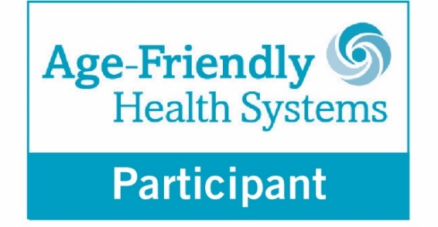This badge is meant to be used by organizations who have submitted their 4Ms Care Description and received confirmation from IHI that they have been accepted as an Age-Friendly Health Systems participant.

We hope that you will proudly display this badge in your care settings and materials.

When your site of care has demonstrated a commitment to care excellence by having: (1)an accepted description; and (2) three consecutive monthly counts of older adults receiving your accepted description of 4Ms Care, you will receive the Age-Friendly Health Systems – Committed to Care Excellence badge.

**Below are a few suggestions for displaying the badge:**

* Promote your participation in the movement on social media with the badge. Please use the hashtag #AgeFriendly.
* Add the badge to your communications (newsletters, presentations, website, email, etc.).
* You can direct people to www.ihi.org/AgeFriendly to learn more.
* Post the badge in your care setting to signal your participation in the movement.

### Written Style

* Age-Friendly Health Systems (capitalized) is an “initiative” (not capitalized) as opposed to a project, program, etc.
* 4Ms Framework for Age-Friendly Care or 4Ms Framework is the focus of the initiative.
* Always hyphenate “Age-Friendly.”
* Avoid the use of an acronym.
* On first mention, please spell out the entire name of the initiative. On second and later mentions, please use “the initiative” or “the Age-Friendly initiative” as opposed to an acronym.
* “Systems” is plural when referring to the initiative. When separately speaking about one health system that has followed the 4Ms Framework, that entity may be referred to as an Age-Friendly Health System — singular and without initial caps.
* Use “clinician(s)” vs. “provider(s).”

### Descriptive Statement

When describing the national initiative, your organization should use the following language:

Age-Friendly Health Systems is an initiative of The John A. Hartford Foundation and the Institute for Healthcare Improvement (IHI) in partnership with the American Hospital Association (AHA) and the Catholic Health Association of the United States (CHA).

### 4Ms and the 4Ms Framework for Age-Friendly Care

4Ms Framework for Age-Friendly Care or 4Ms Framework — initial caps, no space in 4Ms.

4Ms used without the word “framework” refers to the four elements. The 4Ms are “elements” or “essential elements” and not dimensions, components, aspects, etc.

For consistency, use these element descriptions and ALWAYS list the elements in this order:

* What Matters
* Medication
* Mentation
* Mobility

The 4Ms graphics on the next page can be downloaded on www.ihi.org/AgeFriendly and used for related work. The graphics may be used in their entirety without requesting permission.

